Input paper: [1] ENAV20-n.n.n

Input paper for the following Committee(s): check as appropriate Purpose of paper:

**□** ARM **□** ENG **□** PAP **□** Input

X ENAV **□** VTS **X** Information

Agenda item [2]

Technical Domain / Task Number 2 …………………………………

Author(s) / Submitter(s) Maritime Cloud Development Forum:

RISE Viktoria (Sweden)

KRISO (Republic of Korea)

ETRI (Republic of Korea)

Frequentis (Austria)

OFFIS (Germany)

Danish Maritime Authority (Denmark)

Korean Register (Republic of Korea)

KAIST (Republic of Korea)

Maritime Messaging Service

# Summary

This information paper describes the status of Maritime Messaging Service (MMS) infrastructure which is the part of Maritime Cloud. Overall structure of MMS, casting models for message delivery, seamless roaming using message relaying and message queueing and logging scheme for MMS are presented

## Purpose of the document

To give an initial proposal of how an MMS could look like, this paper provides information and background knowledge for discussions on MMS during ENAV20.

It is the end goal of the document to develop a future IALA guideline of describing the MMS part of the Maritime Cloud.

## Related documents

* Maritime Cloud – Conceptual Model (Input paper to ENAV20)
* Identity Management and Cyber Security

# Background

The Maritime Cloud is an initiative towards providing infrastructural functions: registry for digital maritime identity, registry for e-Navigation services descriptions and logical infrastructure for maritime digital communication service. Three multi-partner projects, the EfficienSea2 project, the STM validation project (co-funded by the European Commission) and the Korean SMART-Navigation project – aim to establish and operate such infrastructure functions in the timeframe 2016 - 2018, to demonstrate their value and validate specific services concepts within E-navigation and Sea Traffic Management (the SeaSWIM concept).

MMS is designed as a shore-based messaging service that provides flexible communication regardless of its means for vessels using multiple communication links. It is also designed to include the function to deliver location-based messages such as weather forecasting messages for vessels in specific areas.

# Introduction

Messaging, in particular electronic messaging, takes place in a variety of forms in electronic communication environment. In a legacy network environment such as a campus or a company, transmission of e-mails and short text messages is a typical messaging service available in daily life. In the maritime environment, services such as transmission of weather information, tide information and marine charts are provided through message exchange in addition to the services used in the existing environment. Service registration and ID management can also be done easily in the maritime environment when it incorporates the latest ICT technologies as e-Navigation projects targeted, and therefore various services would appear. For service providers and service consumers who provide and use services through message exchange, efficient and reliable message exchange will be important as the type of service increases.

Compared to the legacy land-based network environment, in the maritime environment there are additional considerations in message exchange. Firstly, it is a characteristic of a ship using various communication means (or communication links). Some communication means have high throughput but have poor coverage (e.g., LTE-M), while other communication means have low speeds but have a good communication range (e.g., HF) which can be used in a ship that sails far from the base station on shore. The ships can change the communication means having the best communication efficiency according to the situation of the means. For this reason, messaging in the Maritime Cloud should take seamless information transfer into consideration between various communication means that has not been considered in the existing messaging systems.

Secondly, many services in the maritime environment require geolocation-based messaging. A typical service may be a risk avoidance service providing weather information to a ship in a specific area or informing a large merchant ship in the vicinity. These services require a message destination to send messages to multiple ships in a specific area rather than a single ship.

In addition, the confidentiality and monitoring functions of messages that are considered in the messaging of legacy communication environments should be considered. Because there could be scurrilous wire tappers between communication parties, encryption of messages has been widely considered in existing environments for confidentiality, especially in the Internet environment, protocols such as Internet Protocol Security (IPSec) or Transport Layer Security (TLS) are widely used. Monitoring of messages from the viewpoint of a network administrator is a necessary function for precise diagnosis of a component that has a problem in message delivery, and is an essential requirement in the maritime communication environment with unstable communication means. In the maritime environment, it should also be able to provide the same function to encrypt and monitor delivery of messages for the message management.

For service providers and service consumers in the maritime environment, it is a burden to provide and consume services by considering all of the problems mentioned above. In addition, implementations of false messaging in a maritime emergency can cause catastrophic events due to message disconnection. Therefore, if the requirements for messaging in the maritime environment described above are supported from an infrastructure perspective and transparently supported to service providers and consumers, it is possible to minimize the error situations that may occur in messaging and reduce the burden for service developer.

There are currently two approaches running: The SMART-Nav project focuses on the Maritime Messaging Service (MMS), while in EfficienSea2 a seamless roaming via a standardized roaming device is currently under development (for further information, see the *Maritime Cloud conceptual model*, a further input paper to ENAV20). These approaches complement each other. The Roaming Device addresses the on-board equipment, while the here described MMS is intended to be a shore-based roaming service, which is provided by the Maritime Cloud as one of the three key elements. The MMS regulates the access request and connects to available communication channels and either benefits from the roaming devices or direct Non-/IP communication devices. The functionality behind is further described below.

# The maritime cloud messaging Service (mms)

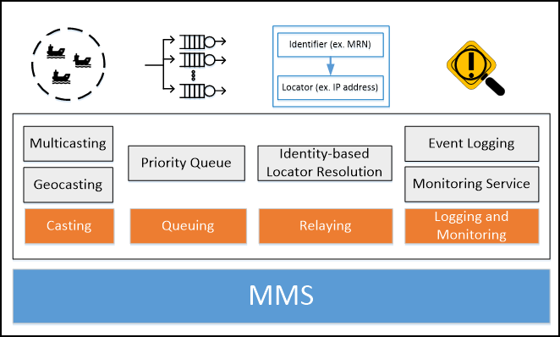

Figure 1 Functionalities of MMS

The MMS has been proposed to serve as a messaging infrastructure for service providers and service consumers to provide transparent messaging requirements in the maritime environment. Here, the service provider and service consumer (generally a ship) can be thought of as an MMS client using MMS. In addition, all MMS clients are connected to MMS, and messages must be delivered through MMS for communication with each other. It is for the message of the MMS Client to satisfy the requirements in the maritime environment by passing through the MMS. Therefore, MMS can be regarded as a message gateway.

In order to meet the messaging requirements in a maritime environment, the MMS aims to provide seamless information transfer between various communication means. Seamless information transfer is required in the cases when messages may not be transmitted to the MMS client because the link status of the communication means is poor, and when the MMS client may not be able to receive some of the messages in the process of changing the communication links. Providing seamless information transfer, when changing the communication links, means to provide seamless roaming capabilities. In the two cases mentioned above, the MMS should be able to provide message queuing function for stable message delivery to MMS Clients. In the case of seamless roaming, it should be able to provide not only the message queuing function but also the function of message relaying that detects the change of the communication links on ship and transmits the messages to the changed links. Seamless transmission of information is covered in detail in Chapter 5.

Next, the MMS must provide location-based messaging functions to its client. To make a little more generalized, the MMS should inherently provide not only unicasting mode but also multicasting and geocasting mode to MMS clients for message delivery. And MMS clients should be able to use it easily. It is discussed in detail in Chapter 6.

Furthermore, the MMS should be able to provide security and monitoring functions that are included in the requirements for messaging services within legacy networks. The monitoring functions required for the MMS and the logging for them are described in detail in Chapter 7. This document does not address security issues on messaging but will cover later in a standardization article.

# Seamless Communication

## Message Relaying

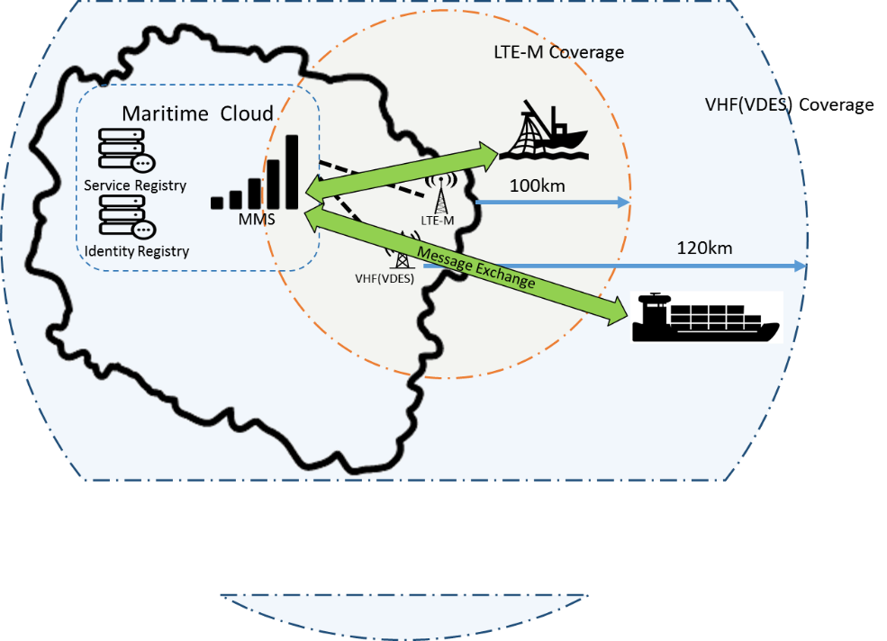

Figure 2 Message Relaying

Since vessels may use heterogeneous communication links, it can be switched to another at any time for better communication. Changing a communication link of a ship will change the network locator (NL, e.g., IP address) of the ship. The NL here indicates the address on the network where a communication means can receive a message. The NL may be an IP address of an MMS client using an IP network or a gateway for performing an IP-to-non-IP conversion for receiving a message on behalf of the corresponding MMS client using non-IP communication. When the NL of the message destination ship changes unexpectedly, messages destined for the ship's previous NL cannot reach the ship. In such situation where the ship's network locator can be changed, there are many restrictions to transmit a message by using the NL. Therefore, message relaying function in the MMS should be able to deliver the messages without any loss even to a vessel that changes its NL flexibly.

While an MMS Client have a unique identifier, the NL of ship can be changed at any time as the MMS Client changes its communication means. For the MMS clients with a flexible NL in the maritime environment, the MMS delivers messages based on the unique identifier of the clients. When a message sender sends a message to the MMS by specifying a unique identifier as its destination, the MMS delivers the message to the current NL of an MMS client that the MMS itself or a separate address translation component has. For the unique identifier, the MRN which can uniquely identify the maritime resources is used. The MRN is defined in IALA [1, 2] and follows the format of uniform resource name [3] defined by the IETF standardization organization (Table 1). For the seamless transfer of information, the MMS uses the MRN to deliver messages between MMS clients.

Table 1 Example of Maritime Resource Name[1]

|  |  |
| --- | --- |
| Examples |  |
| W26 Lighthouse, Great Belt, Denmark: | urn:mrn:iala:aton:dk:021345-w26 |
| Great Belt VTS: | urn:mrn:iala:vts:vtsstation:dk:vtsgreatbelt |
| Ship (the hull): | urn:mrn:imo:imonumber:9250969 |
| Ship (the radiostation): | urn:mrn:itu:mmsi:219543000 |
| Ship (the radiostation): | urn:mrn:itu:callsign:xp4358 |

If MMS clients know each other's destination MRN, the destination MRN is loaded into the message to be delivered and sent to the MMS, and thereby the MMS ensures to seamlessly deliver the message to the MMS client who has the destination MRN. Only with the MRN of a destination entity, a maritime entity sending a message can deliver its message. This even does not require neither of the NL of the destination and any information of destination’s location or its communication means. For example, if a service provider sends a message to the MMS destined for the MRN of a merchant ship using VDES, the message can be seamlessly transferred to the merchant ship just with the given MRN.

## Message Queueing

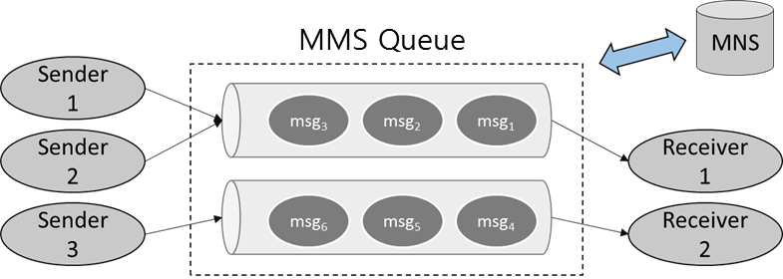

Figure 3 Message Queueing

If communication links between the MMS and its MMS clients is not stable, messages between MMS clients may not be delivered. In this case, the MMS should store the messages in its internal queue for a while to ensure message delivery. When one or more of communication links are restored, to the MMS resends the messages in the queue to the destination MMS clients.

The message queue of the MMS can also be designed to support various queuing policy settings. For example, the MMS can store messages in different queues according to the destination MRNs and to determine whether or not to queue a large-capacity message according to a communication method of the ship. Also a policy to deliver higher priority messages prior to lower ones can be set. The message queuing policy is for efficient and effective message delivery with flexibilities.

# Message Casting

One of requirements of the Maritime Cloud is to create an environment where service providers can easily provide location-based services. For example, a service provider that provides weather information of specific areas may be developing a service that provides weather information to a number of vessels in a specific area. If a technology is provided to transfer messages to multiple MMS clients at the same time based on the location information by MMS, the service provider can provide the service without implementing the function of managing the latest location information of the service consumer and transmitting the message to multiple consumers.

For this purpose, the MMS should provide casting technology including unicasting, multicasting and geocasting. Unicasting can be supported through the relaying technique described above, but additional technical support is needed for multicasting and geocasting. Since geocasting is a special case of multicasting, in this chapter the term multicasting is described as a concept that includes geocasting.

In the case of multicasting in the address structure of Internet Protocol(IP), through a standardized multicasting IP address, it specifies that the address is for multicasting. For example, in the IPv6 Address Architecture standard [4], upper 8 bits are indicated as FF00 :: / 8 to indicate the multicasting address and the information related to multicasting is displayed in the remaining bits. Similarly, in the case of multicasting in the MMS, a special address "Multicasting MRN" indicating multicasting can be defined. When a multicasting MRN is defined, the MMS Client can easily specify the multicasting address and can judge and process it in MMS.

Multicasting should be considered together with security considerations. If it is not taken into consideration, flooding attacks can be executed on many MMS clients, and will cause damages such as bandwidth and denial of service. Therefore, the MMS client that intends to perform the multicasting needs to consult in advance about the right to send the message to the MMS clients belonging to the destination multicasting domain. If the right is not discussed in advance, the unwanted MMS client should be blocked from receiving the multicasting message.

# Logging and monitoring

Logging in the MMS is to record events that occur within it during its operation. For example, there may be a case where a connection with a ship is disconnected and that situation has been recorded. The monitoring funtion provided by the MMS analyzes the log generated during the message transmission between the MMS clients. The MMS can provide the logs for interpretation or evaluation of quality of services. For example, if there is a log of disconnection from a ship and a log of reconnection, the ship may be belived to enter and leave the shaded area.

Logging for monitoring in the MMS is very important. MMS operates as a gateway through which maritime messages are exchanged. Therefore, the MMS needs to have the ability to log message exchanges by each maritime entity or the connection status of each entities. Especially, the MMS can provide monitoring function of service status or ship connection status through log analysis.

In order to perform logging in the MMS, it is necessary to determine the log format. The log formats include syslog [5] defined in RFC standard, Extended Log File Format [6] submitted as W3C standard agenda, Common Log Format [7] log format of widely used National Center for Supercomputing Applications (NCSA) . In case of ship, because it has mobility, it is necessary to record through the MRN which is unique ID, not to record the NL of the source or destination as the key value when recording the event of the ship to be logged. For this reason, it is necessary to log MRN of the ship using log format that is easy to expand without using existing log format based on existing IP address. The syslog or Extended Log File format, which is often used as a log format, is easy to expand and can be used in the MMS because MRN information can be displayed in the log.

# References

[1] ENAV18-14.1.19 “Liaison Note to PAP on Maritime Resource Names MRN post plenary,” ENAV18, IALA, 2016.

[2] “Maritime Cloud Identity Platform,” http://developers.maritimecloud.net/identity/index.html

[3] “Uniform Resource Names (URN)”, IETF, https://www.ietf.org/rfc/rfc3406.txt.

[4] R. Hinden, S. Deering, “IP Version 6 Addressing Arhitecture,” RFC 4291, 2006.

[5] <https://tools.ietf.org/html/rfc5424>

[6] https://www.w3.org/TR/WD-logfile.html

[7] https://httpd.apache.org/docs/trunk/logs.html#common

1. Input document number, to be assigned by the Committee Secretary
2. Leave open if uncertain